**How To Set Up Kingyan’s First And Third Person Controllers**

**Setting Up The Controllers And Understanding How They Work**

***1- Gravity, Collision Detection And Layer Masks.***

The controllers checks whether or not the player is on the ground by using a Layer Mask, as long as the Ground Check Sphere does not come in contact with an object that has the “Ground” layer a force simulating gravity will be applied to the player.

Thus you should set any object’s layer that the player may walk on mask as “Ground” (Note: layers and tags are separate, so you can still put a tag on a “Ground” object). If you don’t, the players momentum will keep increasing, this obviously can cause some problems.



Before using the controllers, you should check the “Ground Mask” variable in the prefabs and set it to “Ground”, if this option doesn’t appear, create a new layer.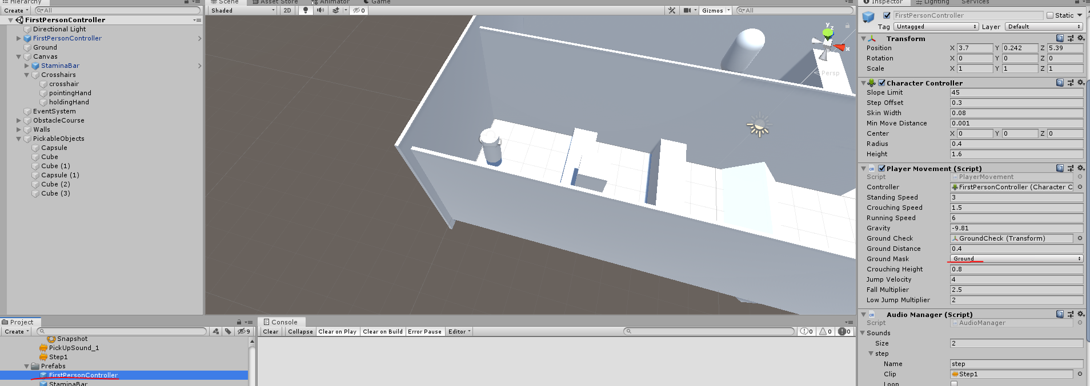

Note: The Controller doesn’t use a “Rigidbody” for the physics but instead uses an older component called “CharacterController”, this means functions like “AddForce()” or “AddTorque()” don’t exist but instead functions like “Move()” or “Rotate()” and a variable called “velocity” are used.

Other note: The player is capable of climbing 45° slopes and some stairs. The slope limit can be modified in the “CharacterController” using the “SlopeLimit” variable.

***2 - Pickable (And Throwable!) Objects***

For the “Pick and Throw” feature to work, the scene MUST have objects called “crosshair”, “pointingHand” and “holdingHand” (WARNING: Not having these objects in the scene WILL result in a NullReferenceException), ideally these would be icons in the center of the screen made to indicate to the player if they can take an object or if an object is already taken. For simplicity, you may copy and paste these from the demo scenes. All the pickable objects should have a “ThrowObject” and a “AudioManager” script, the AudioManager should have two sounds in it called “collisionSound” and “pickUpSound” , the sounds themselves can be different from the exemple but the name should be the EXACT SAME. The force at which the object are thrown can be modified as the “ThrowForce” variable in the “ThrowObject” script.

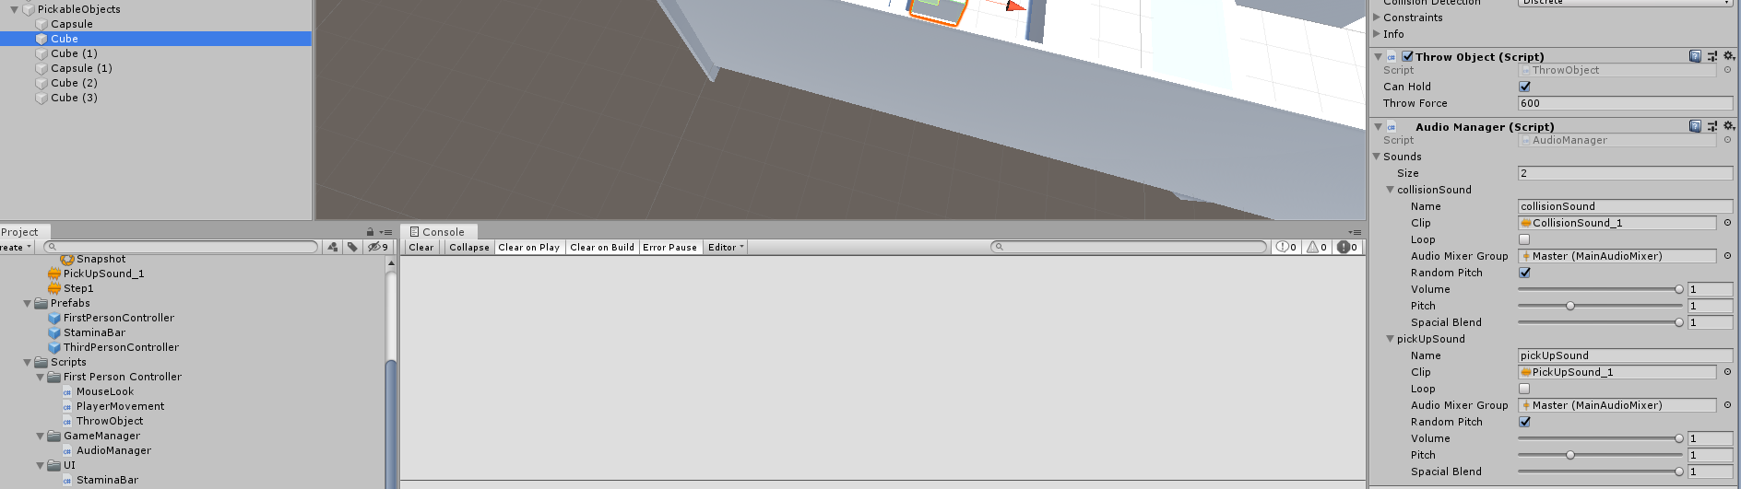

***3 - Sprinting And The Stamina Bar***

The “Sprinting” can work without a slider with the “StaminaBar” script in it but .

it is recommended to have one within the scene.

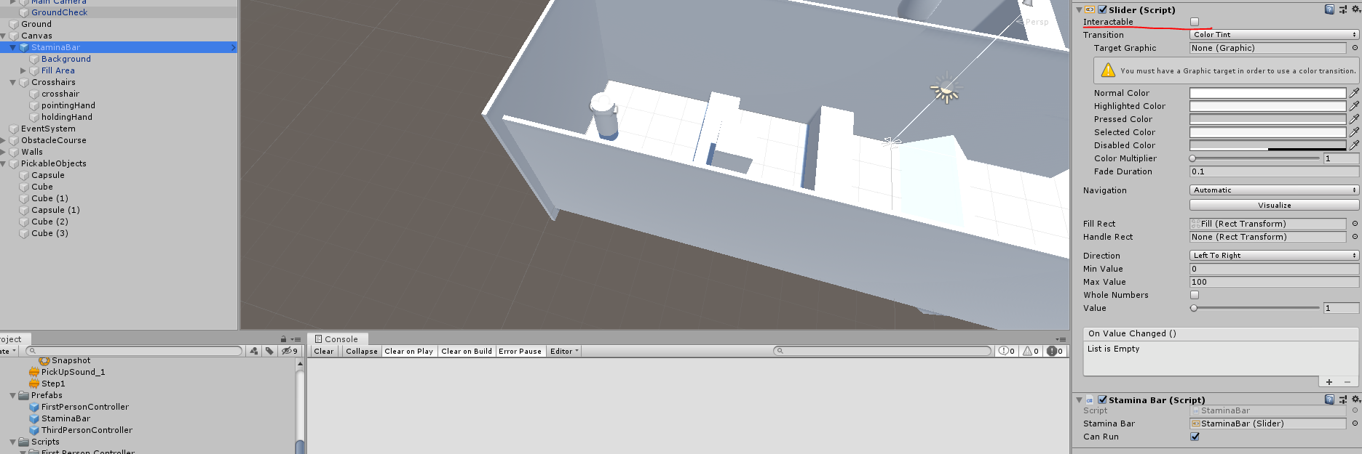

***4 - The AudioManager***

The controllers doesn’t directly use the “AudioSource” component for the sounds, it uses a script that goes through an array of “Sound” variable then creates “AudioSource”, it’s basically the same thing but more organized. You can still use the “AudioSource” component.

***5 - Miscellaneous features***

The mouse sensitivity can be modified using a variable called “mouse Sensitivity” on the “MouseLook” script (attached to the camera in the prefabs).

You can switch between FPS and TPS modes by pressing V.